# Exercise 3 : Git-HOL

### Step 1: Create a Repository

* Go to GitHub or GitLab and log in.
* Click on 'New Repository'.
* Enter repository name: GitHandsOnLab
* Choose visibility and initialize with a README.
* Click on 'Create Repository'.

### Step 2: Check Git Status

* git status

### Step 3: Create a New Branch

* git checkout -b GitNewBranch

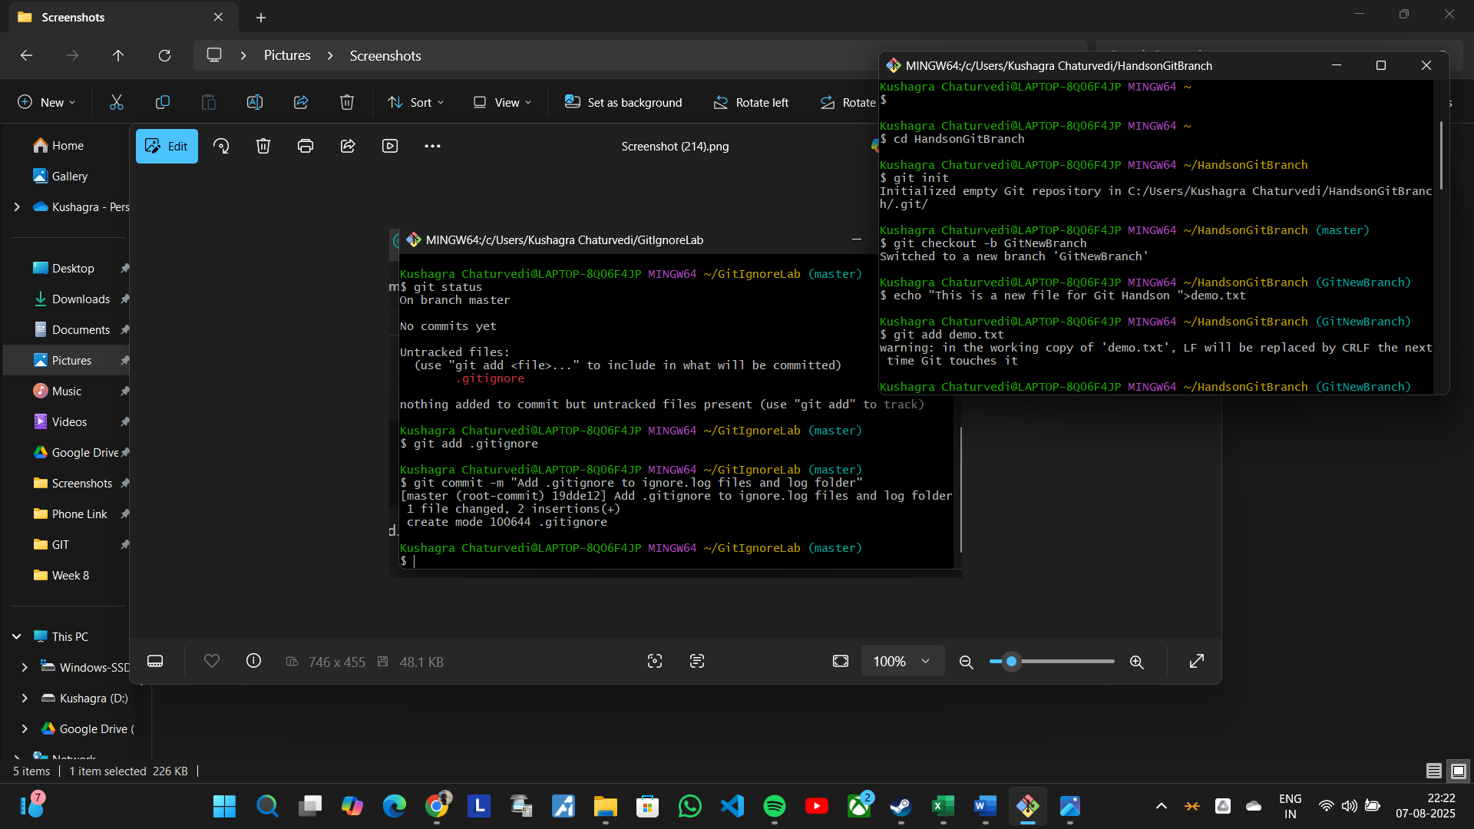

### Step 4: Create a File and Add Content

* echo "This is a new file for Git hands-on." > demo.txt



### Step 5: Stage the File

* git add demo.txt



### Step 6: Commit the Changes

* git commit -m "Added demo.txt in GitNewBranch"

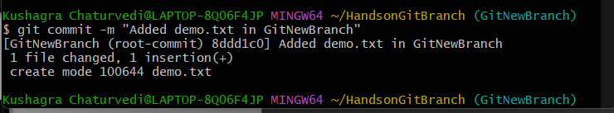

### Step 7: Check Branch and Status

* git branch
* git status

### Step 8: Switch to Master/Main

* git checkout master



### Step 9: View CLI Differences

* git diff master GitNewBranch

### Step 10: View Visual Differences with P4Merge

* git config --global merge.tool p4merge
* git config --global mergetool.p4merge.cmd "C:/Program Files/Perforce/p4merge.exe" "$BASE" "$LOCAL" "$REMOTE" "$MERGED"
* git difftool master GitNewBranch

### Step 11: Merge the Branch

* git merge GitNewBranch

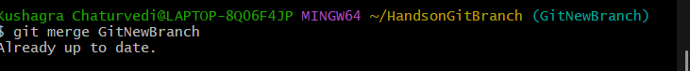

### Step 12: View Commit Graph

* git log --oneline --graph –decorate



### Step 13: Create Merge Request (on GitLab or GitHub)

* Go to your repository in browser.
* Click 'Compare & Create Merge Request'.
* Select source: GitNewBranch, target: master/main.
* Add title and description.
* Click 'Create Merge Request' and then 'Merge'.

### Step 14: Delete Remote Branch (Optional)

* git push origin --delete GitNewBranch